Michael Yorkell

presents

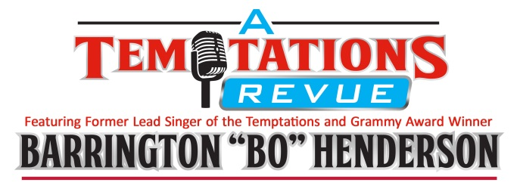

A Musical Journey through The Temptations Catalog

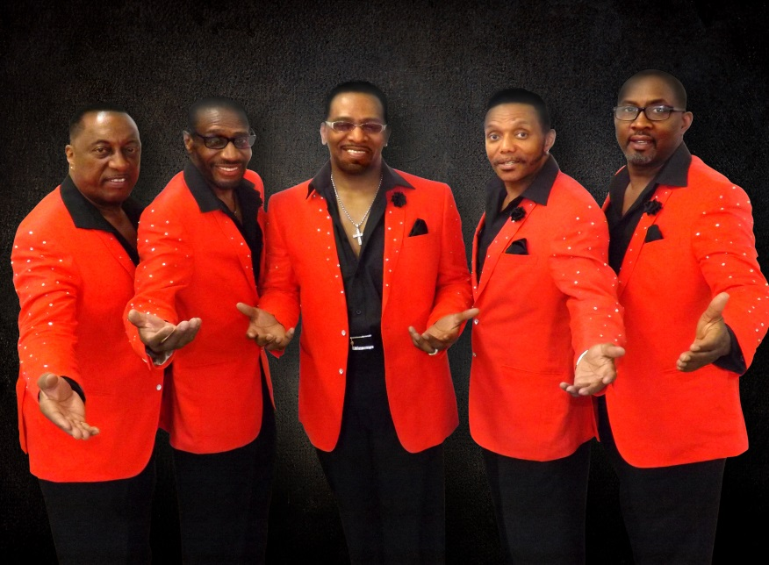

Bringing the unforgettable songs of the Temptations back to your venue is A Temptations Revue featuring former Lead Singer of the Temptations (1998-2003) and Grammy Award Winner Barrington “Bo” Henderson. This dynamic and driving tribute spans more than a decade of Temptations classics – every one of the songs performed are among the most recognizable and culture-defining songs in pop music history.

The show features five of the best male vocalists performing Motown music in the US today, all of which have sung with many of the other 22 male vocalists to have fronted The Temptations since its inception back in the early 1960’s, including the late great Richard Street and Ali-Ollie Woodson.

This show features the great harmonies and choreographed dance steps that made The Temptations famous and features a 6 piece back-up band that is a show in itself. The musicianship is second to none and many of the players have backed up or opened up for many of the original Temptations’ singers.

Barrington “Bo” Henderson- Bo has sung on many stages throughout his career and has toured the world with The Temptations, Lakeside and The Dramatics. He also had the distinct honor of performing for the King and Queen of Denmark.

Larry Johnson -Donald has been singing Motown, R & B and Gospel his entire life from the age of 5. Larry’s amazing falcetto has taken him around the world in the music business performing with such groups as Richard Street’s Temptations, Ali Woodson’s Emperors of Soul and Heatwave.

Lawrence Jones- AJ Smooth has been performing his amazing vocals for over thirty years and is still making the ladies swoon with his warm vocal renditions of the great Motown hits.

Steven Wood- Steven’s bass vocals and smooth dance moves make him one of the most sought after performers in the Motown genre. Steven performed on the Richard Street Legacy Tour with the Temptations.

Terry Horn- A native of Detroit, Terry’s toured with the legendary Ali Woodson of The Temptations and Richard Street’s Temptations Revue. He’s also performed extensively with the Michigan Opera Theatre in over twenty productions, and he’s toured in the UK, Germany, France, Malaysia, Japan and Guam.

Let’s Meet the Band

Drums: Richard “The Power Station” Marshall, Musical Director
Saxophone, Flute-Rodney Caron
Trumpet- Don Chilton
Guitar-David Boudah
Bass-Rudi Weeks
Keyboards/Piano-Pat Jennings

PRODUCTION STAFF
Producer/ Manager Michael Yorkell
Director Michael Yorkell
Production Manager Darren Lussier
Sound Engineer Darren Lussier
Musical Director Richard Marshall
Booking Agent ECE Touring

